End-of-year test
Disclaimer: Please note that these mark schemes have not been produced by Cambridge Assessment International Education. They have been written by the author of the tests.

1 a From top to bottom: crust, mantle, outer core, inner core

b Inner core

c Mantle

d The Earth is shaped like a ball.

The diagram clearly shows the layers inside the Earth.

2 Missing words are skeleton, pull, pairs, contracts, relaxes

3 a Underline Copper, Seawater, Aluminium, Steel

b Less brightly than before

c More brightly than before

d The same as before

4 a The time taken for the bead to drop off the spoon

b The temperature

c 8 minutes

d It takes less time for the bead to drop off the spoon as the temperature increases (or similar)

e The water gains energy as it is heated. This means the water has more energy that can be
transferred/move to the spoon to make the bead fall off quicker.

5
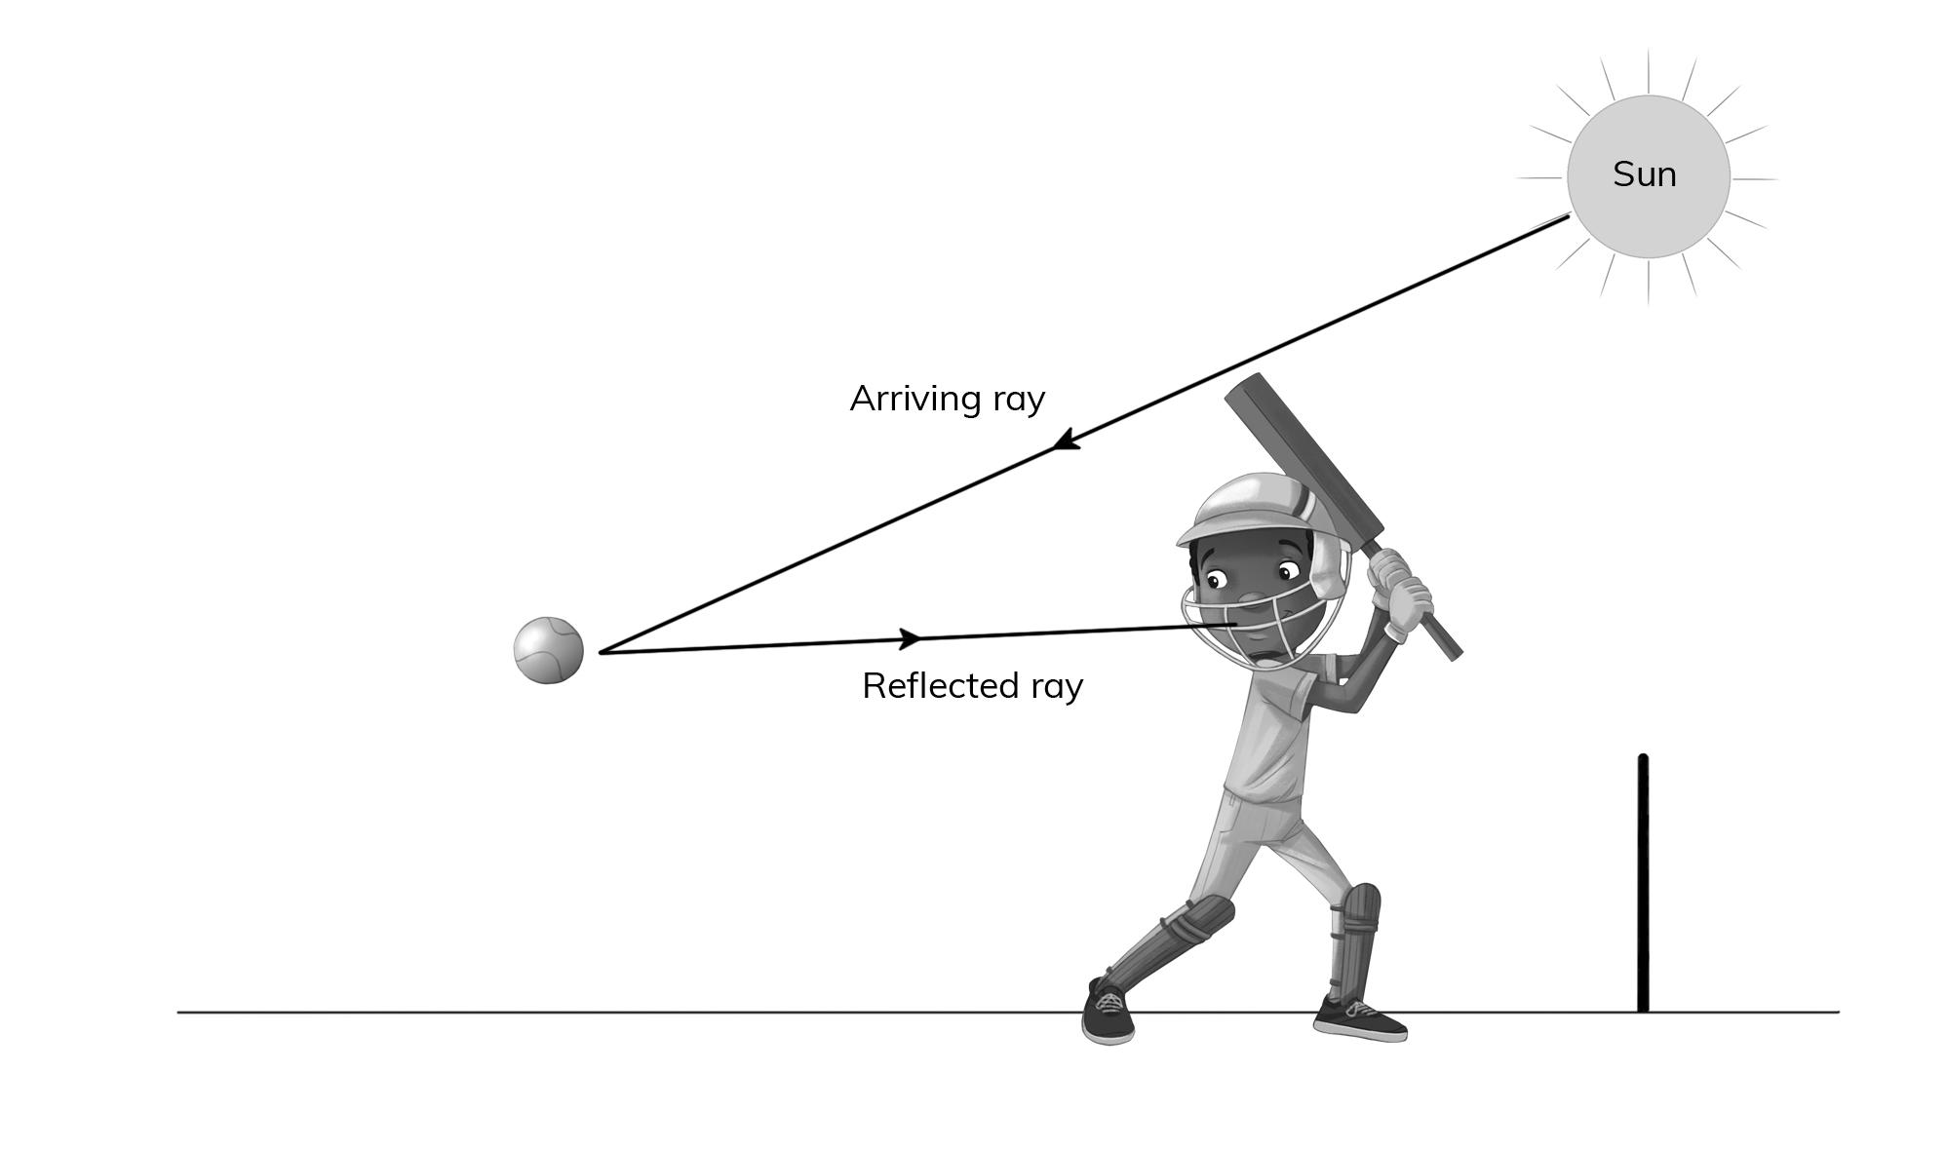

Award marks for: correct ray and arrow for arriving ray, correct label for arriving ray;
correct ray and arrow for reflecting ray, correct label for reflecting ray.

6 a A: Magma

B: Earth’s crust

C: Secondary cone

D: Crater

b Composite volcano
7 | Shape of beak | Short | Long | Flat | Pointed | Hooked
 | A bird that lives next to a river and eats fish |  | ✓ |  | ✓
 | A bird that lives in grassland and eats seeds | ✓ |  |  |  | ✓

8 a A substance is a pure type of solid, liquid or gas.

b B

^{c} 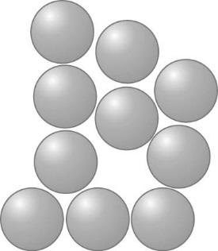

9 a The point on the Earth’s surface above the focus which is where the earthquake begins.

b A tsunami is a huge sea wave.

c The tsunami will flood the coast and people can drown.

d Japan is on the Pacific Ring of Fire.

10 a The Earth is spinning on its axis.

b Day and night

c
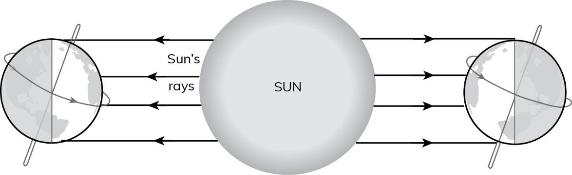

d The sides facing away from the Sun are having night.

